Spatial-Sequence Synesthesia (SSS)

🧠📅 What is Spatial-Sequence Synesthesia (SSS)?
# Source: AI Source: Provided by: [Data Path: Persons Table -> ID Column: 1, Name_En Column: Motasem Essam] -> From: [Chatgpt (GPT-4-turbo)] on [7/24/2025]
Spatial-sequence synesthesia is a type of synesthesia in which a person automatically visualizes sequences (like days, months, numbers, or years) as arranged in space — often with specific positions, shapes, or directions in their mind’s eye.

📘 Definition:
# Source: AI Source: Provided by: [Data Path: Persons Table -> ID Column: 1, Name_En Column: Motasem Essam] -> From: [Chatgpt (GPT-4-turbo)] on [7/24/2025]
Spatial-sequence synesthesia is a neurological condition where ordered sequences (like time or numbers) are experienced as having specific spatial locations or forms, even when they are not visible.

🧠 Common Triggers & Responses:
# Source: AI Source: Provided by: [Data Path: Persons Table -> ID Column: 1, Name_En Column: Motasem Essam] -> From: [Chatgpt (GPT-4-turbo)] on [7/24/2025]

Trigger | Mental Spatial Form
Days of the week | Monday is to the left, Friday is below you
Months of the year | January is above, December is behind you
Numbers | 1–10 is a line, 11–20 curves upward
Years | 1900–2000 might form a spiral or ladder

🧒 Example:
# Source: AI Source: Provided by: [Data Path: Persons Table -> ID Column: 1, Name_En Column: Motasem Essam] -> From: [Chatgpt (GPT-4-turbo)] on [7/24/2025]
A person might "see" the calendar year like this:
- January on the top left
- June in front
- December below and behind
Even though there's nothing physically there, the visualization is vivid and consistent.

Spatial-Sequence Synesthesia photo
# Source: Windows ScreenShots at [7/26/2025]
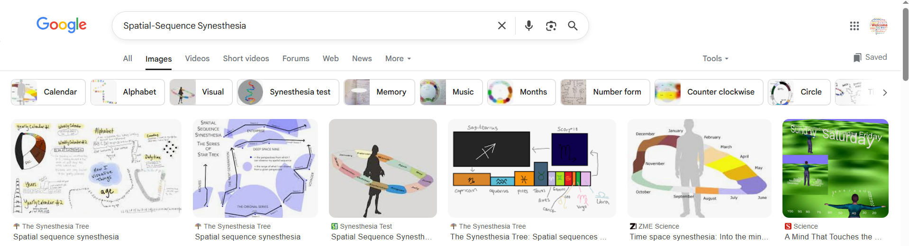
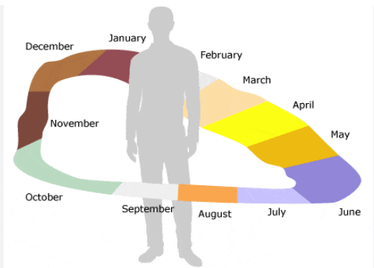
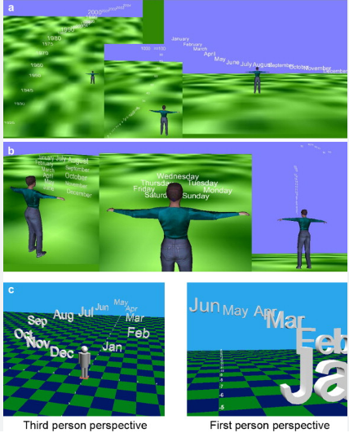

💡 Key Features:
# Source: AI Source: Provided by: [Data Path: Persons Table -> ID Column: 1, Name_En Column: Motasem Essam] -> From: [Chatgpt (GPT-4-turbo)] on [7/24/2025]
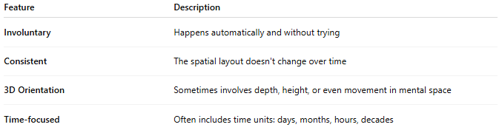
Feature | Description
Involuntary | Happens automatically and without trying
Consistent | The spatial layout doesn't change over time
3D Orientation | Sometimes involves depth, height, or even movement in mental space
Time-focused | Often includes time units: days, months, hours, decades

🧬 How It Works:
# Source: AI Source: Provided by: [Data Path: Persons Table -> ID Column: 1, Name_En Column: Motasem Essam] -> From: [Chatgpt (GPT-4-turbo)] on [7/24/2025]
- Linked to cross-activation between:
  - Ordinal processing areas (handle sequences)
  - Parietal lobe (handles spatial relationships)
- Related to number–form synesthesia, but not limited to numbers.

🔁 Spatial-Sequence vs Number–Form:
# Source: AI Source: Provided by: [Data Path: Persons Table -> ID Column: 1, Name_En Column: Motasem Essam] -> From: [Chatgpt (GPT-4-turbo)] on [7/24/2025]
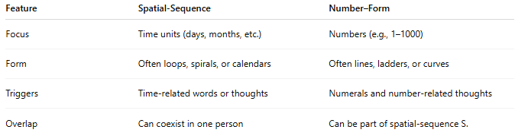
Feature | Spatial-Sequence | Number–Form
Focus | Time units (days, months, etc.) | Numbers (e.g., 1–1000)
Form | Often loops, spirals, or calendars | Often lines, ladders, or curves
Triggers | Time-related words or thoughts | Numerals and number-related thoughts
Overlap | Can coexist in one person | Can be part of spatial-sequence S.

✅ Summary:
# Source: AI Source: Provided by: [Data Path: Persons Table -> ID Column: 1, Name_En Column: Motasem Essam] -> From: [Chatgpt (GPT-4-turbo)] on [7/24/2025]
Spatial-sequence synesthesia is when a person sees time or ordered sequences arranged in mental space — like a calendar wrapping around the body or a timeline stretching outward.
It’s involuntary, highly consistent, and a unique blending of time and space in the brain.

